**AN ALTERNATIVE GRIND FOR THE SKEW CHISEL**

**Alan Lacer**

Geometry: 70 degrees from point to point; ground bevel angle (equivalent to bevel length) is expressed as 1.5 x steel thickness; behind the short point’s bevel a full round to the end of the blade; behind the long point’s bevel a flattened surface but with the corners removed.

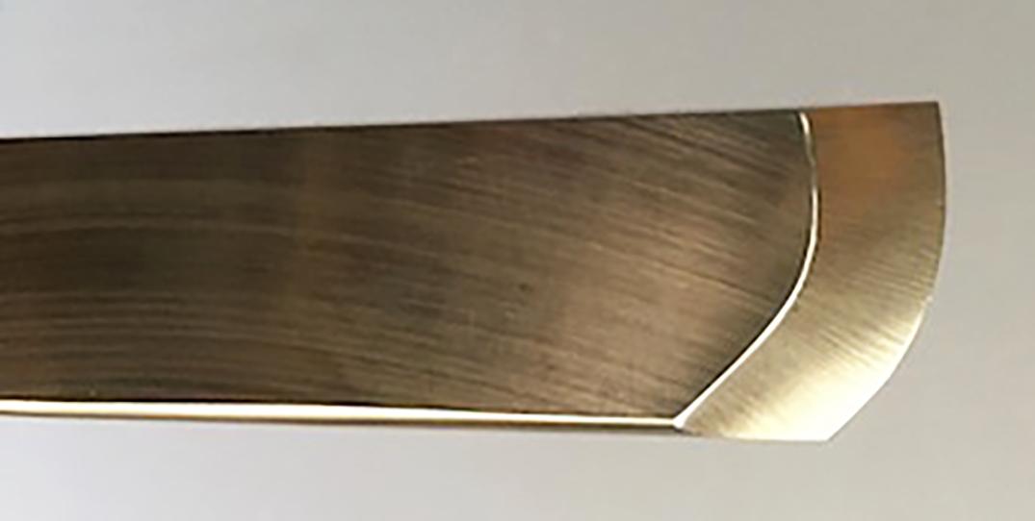

ADVATAGES:

1. “Tells” you where to cut for planing and rolling cuts (cut where curved)
2. For planing and rolling cuts gives increased clearance angle for the trailing point and trailing edge
3. Gives between 15% and 20% more cutting edge
4. For peeling cuts is self-limiting
5. For peeling cuts puts the handle at a right angle to the axis of lathe
6. Straight section used for scraping actions
7. Straight section used for finishing cuts on rounded pommels
8. Curved edge works better on “chippy” or figured woods

9. Curved edge has lower impact when planning or rolling, has a progressive entry into the wood, better at shearing the fibers

10. Curved edge works better for concave cuts (a curve fits a curve better)

DISADVANTAGE: Harder to sharpen than a traditional ground skew.

For sharpening two sizes of skews with this grind see Alan on YouTube:

https://www.youtube.com/watch?v=dmCxDToHm6Y&t=19s