Misc Items

I received an e-mail from a former student, Marc Anderson. I think he and his wife, Sue, were former members for a while. Basically he has an EcoGate automatic gate system for dust collection systems. (you can control which gates are open electronically and with a flip of a switch. ) He is looking to sell the system. He is asking $500. Anyone interested, contact Marc directly at [marc@lindasbakery.com](mailto:marc@lindasbakery.com) or 608-386-0472. In case you recognized the e-mail address, Marc and Sue are the owners of Linda’s Bakery in West Salem. Here are some pictures of the system:

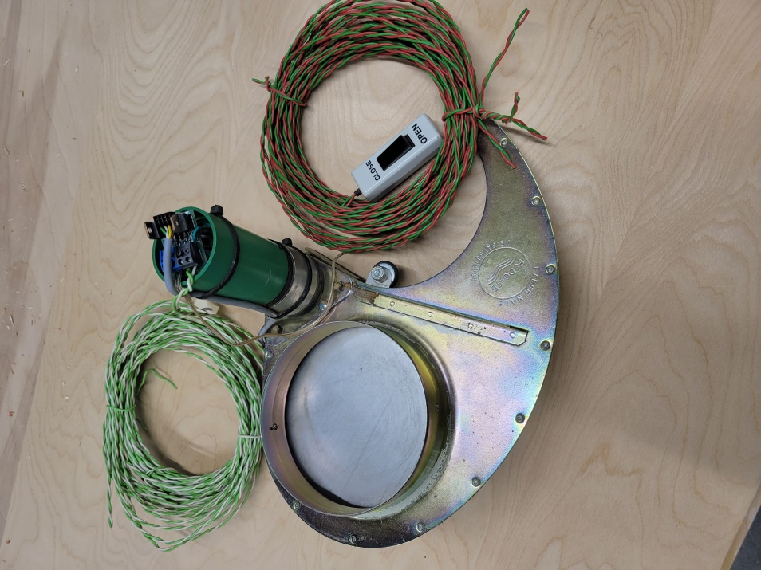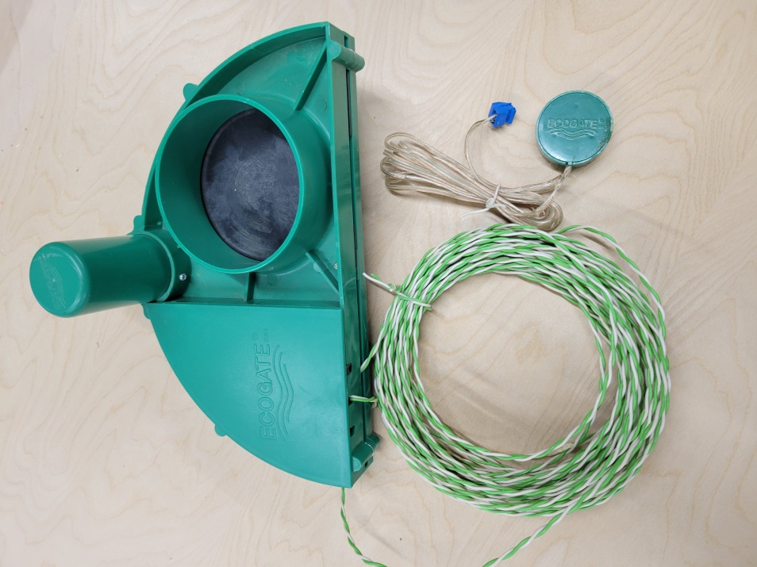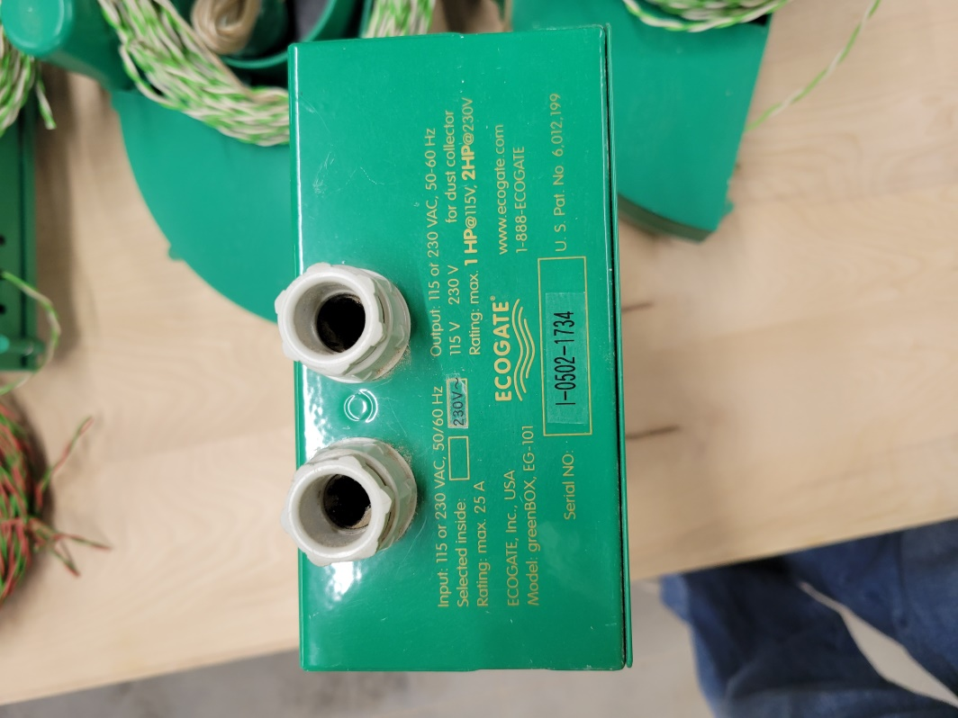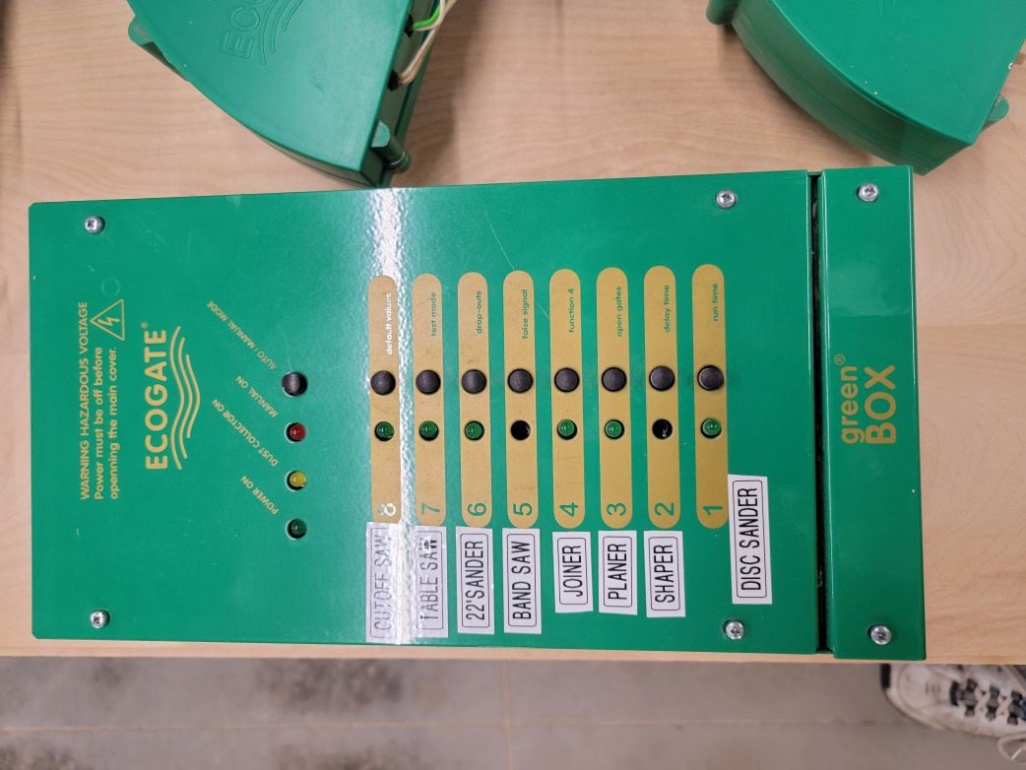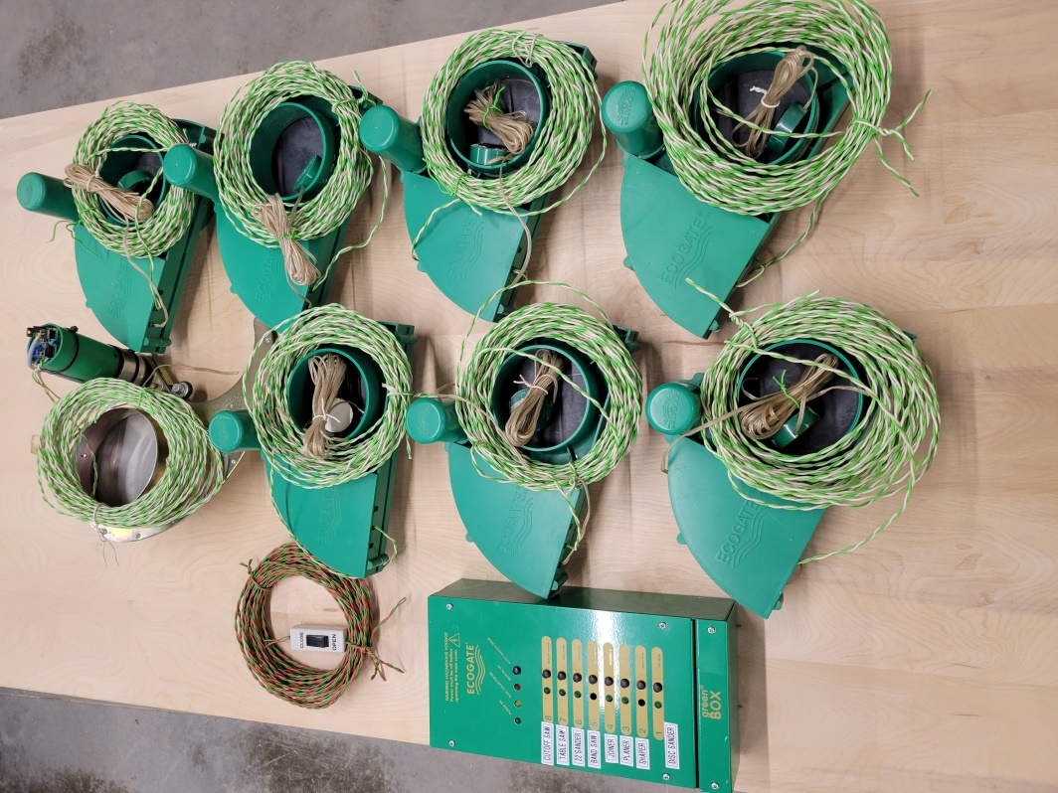

I also have two items for sale/give away. I have a wooden cart that I used to hold my class grinder. The cart is 30” wide x 21” deep x32” high. It has 4 locking casters. Here are a couple of pictures of the cart:

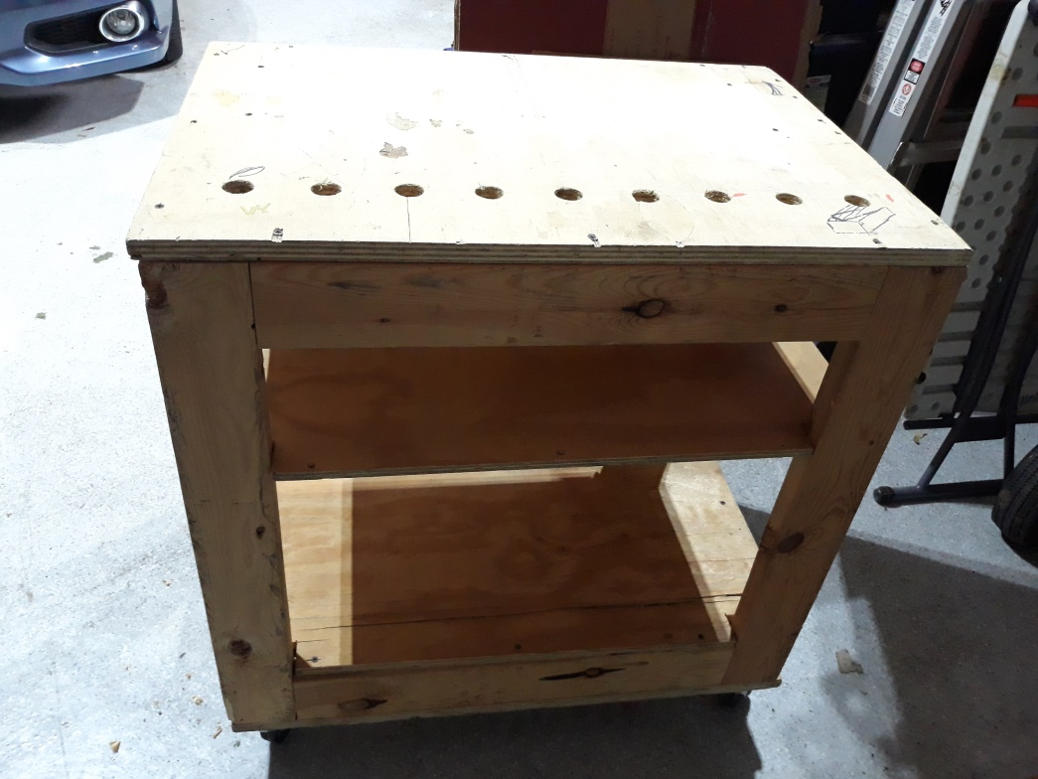

The cart is for free. You come pick it up and it is yours.

The second item is a chop saw stand. I bought this at Menards and it works well. Here is a picture of the stand:

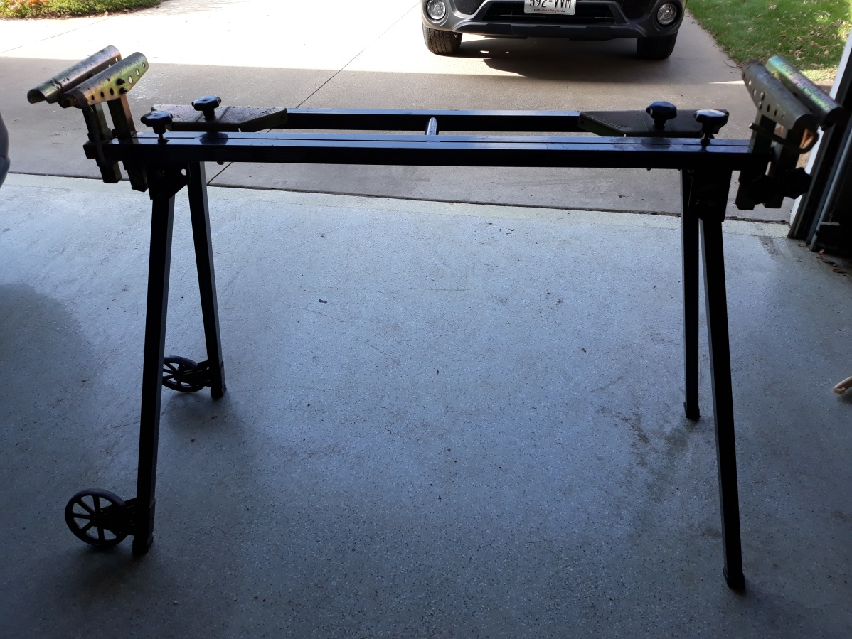

Not pictured is the mounting board for the saw, which is included with the stand. The stand can expand to various lengths of wood. It is very study and will fold up for storage. I would like to get $25 for the stand.

If you are interested in either the cart or stand, give me a call at 608-397-9526 or email me at wisawdust@charter.net.