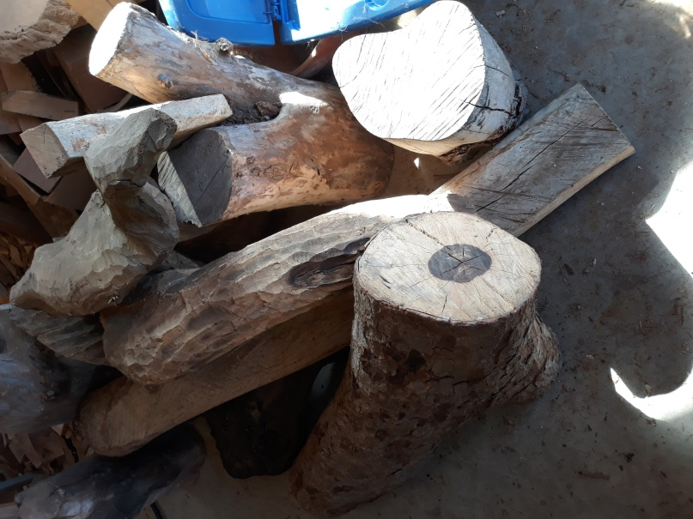

Pics of some of the Koa at Rob’s place

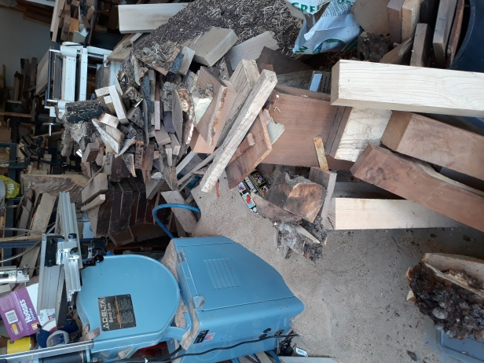

Rob’s band saw. Notice the pile of shavings and the stack of 8 quarter walnut for sale

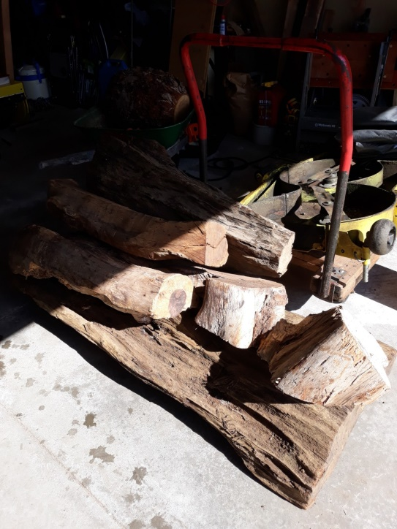

More Koa

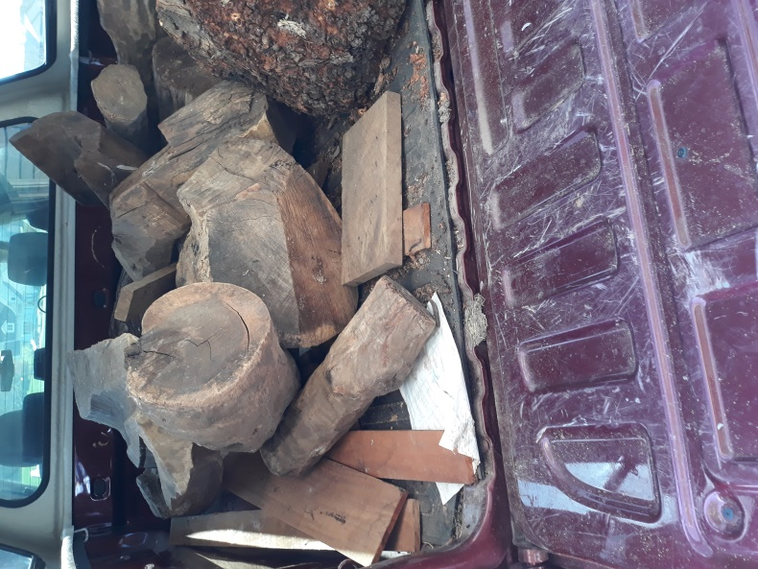

Koa in his truck bed.