For Sale

See Duane Hill

I have several items for sale. I someone is interested in a particular item, let me know and I will bring it to the April meeting.

1). ShopVac Air Cleaner – works well $30

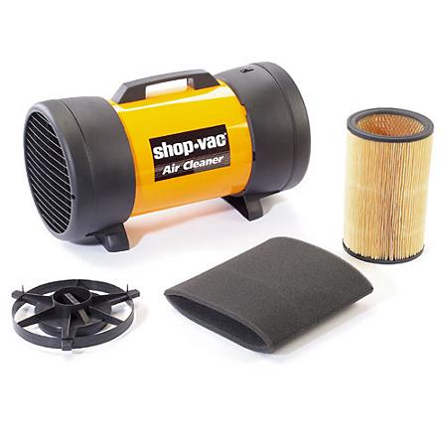

About this item

• Filters the air in a 290 sq/ft room every 10 minutes

• Lightweight yet durable

• Removable end grill for convenient filter maintenance

• 2 year manufacturer's warranty

2). Sears Craftsman Reciprocating Saw with tool bag - $25

3). Larin 2 ½ ton floor jack with case - $25

4). Oneway VariGrind 2 Jig - $25

5). Oneway Skew Grinding Jig (fits the long bowl grinding bar) - $20

6). Ring Master ring cutting tool - $200

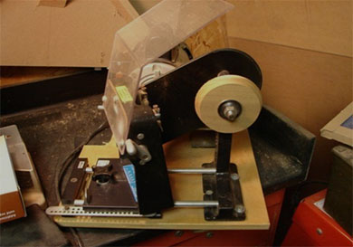

If you are interested, call Duane Hill at 608-397-9526 or e-mail at wisawdust@charter.net