

What’s Happening:

March TAG Meeting – 3/6/19 at 4:30 PM, in the Commons Room of the Area Community Theater Building, 901, Kilbourn Ave., Tomah, WI

Further dates to be announced.



Monthly Newsletter for March 2019

Hello Everyone! We hope you enjoy this update on what our Guild is doing, and our upcoming events.

Come check us out! Our Guild is looking for new artists, supporters of the arts, or community-minded people to become members. More hands would allow us to do more for the arts in our area.

Please feel free to share our newsletter with anyone who may be interested. If you would like to be removed from our mailing list, please let us know at tomahartsguild.com.

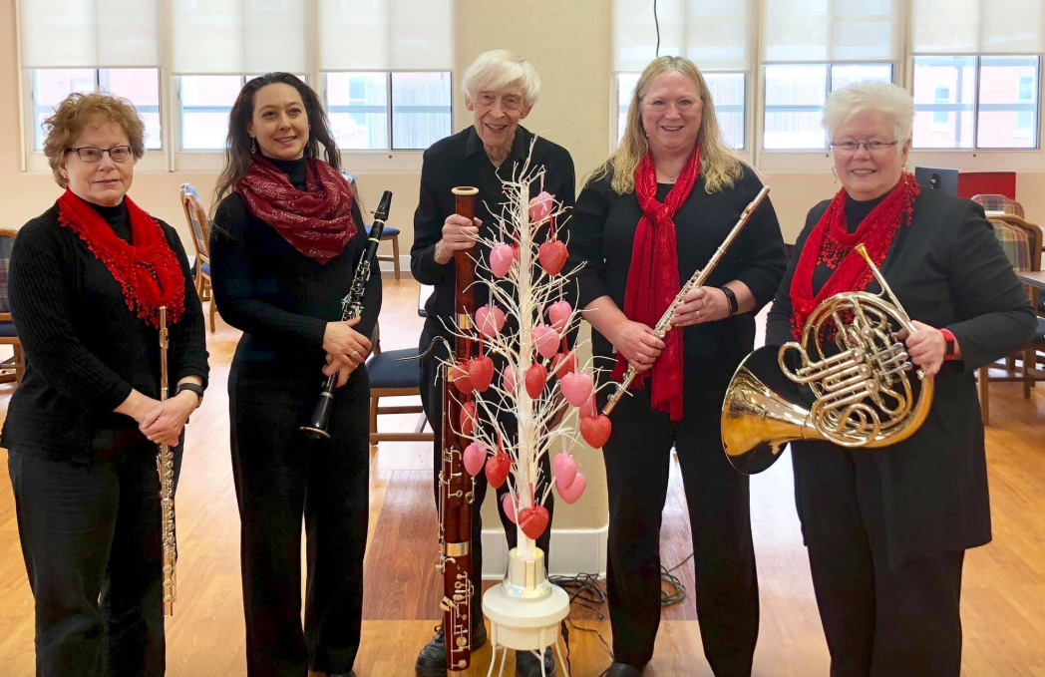

Artists: River Winds Quintet

Medium: Music

A guy in Paris nearly got away with stealing from the Louvre. However, after escaping with the goods, he was captured only two blocks away when his van ran out of fuel. When asked how he could mastermind such a crime and then make such an obvious error, he replied: “I had no Monet to buy Degas to make the Van Gogh.”