Wood Lathe, copy attachment and tool set for sale:

A friend here in Lancaster, WI has a Grizzly G1495 wood lathe for sale. She is an excellent woodworker and thought she would use the lathe more but it is not getting used so she wants to get rid of it. She said the only time she used it was to make 4 table legs. I have seen it but I have not used it. She is asking $940 for the lathe, $300 for the copier, $20 for 2 extra cutters for the copier and $50 for the chisels w/case. Her name is Kathy Addison and her phone number is 608-723-7981. If you are interested give her a call. She might be willing to negotiate.

Grizzly G1495 Wood Lathe
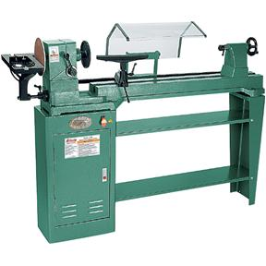
Description
A high-quality, heavy-duty cast iron bed wood lathe that we were almost "ordered" by our customers to bring in! This is one of the best package deals we offer. We ask you to compare all the features and accessories to others on the market, we are confident enough to say this is the best value out there. Call and ask for a reference.
An instant "hit" when introduced in early 1988, this lathe has proven to be an excellent performer!
Features
- Swing over bed: 14"
- Swing over gap: 17"
- Distance between centers: 40"
- Spindle size: 1" x 12 T.P.I. R.H.
- Spindle taper: M.T. #2
- Tailstock taper: M.T. #2
- Motor size: 3/4 H.P., single phase, 110V/220V
- Indexed spindle - 30°
- 7 speeds: 500-3070 R.P.M.
- Center-to-floor height: 41-1/2"
- Outboard spindle size: 7/8" x 16 T.P.I./ LH
- Shipping weight approx.: 281 lbs.
Package Deal Includes:
- Cabinet Stand & Shelves
- 3/4 H.P., 110/220V Motor
- 8" sanding disc
- 6" face plate
- Live Center/Spur Center
- Flap sander
- Pneumatic Drum Sander
- Two Tool Rest Mounts
- Aluminum Sanding Table
- Miter Gauge

See pages 10, 125, and 129 of our 2010 Grizzly Catalog!

Grizzly G2891 Copy Attachment for G1495/G1067Z

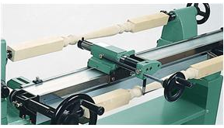
Description
Make multiple copies from a template or master workpiece. If you have stair railing spindles or lots of chair or table legs to produce, our G2891 will make your life much, much easier.

See page 125 of our 2010 Grizzly Catalog!

Grizzly H7924 6 pc. Lathe Chisel Set in Aluminum Box

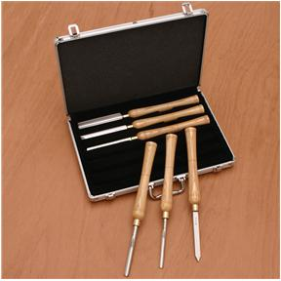
Description
- High speed steel blades
- Graceful ash handles provide plenty of control
- Handles measure 10" long and chisels measure 15-1/2" long overall
- Set includes a 3/16" parting tool, 1/2" round nose, 7/8" skew, 3/8" gouge, 1/2" gouge and 1" gouge
- All chisels are protected in a tough aluminum case

See page 133 of our 2010 Grizzly Catalog!

