Needle and Thread Holder
Adapted from http://teknatool.com/projects/Travelmate_Dick%20Veitch.pdf by Kris Clough.
Most of the dimensions can be modified. Dimensions that need to correspond to each other will be marked with an *. The head stock is located at the left and the tail stock at the right in all of the drawings below.
Start with two pieces of wood about ¾” in diameter by 4-5” long.

Cap
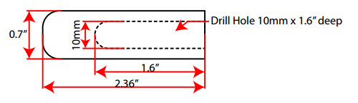
Round a blank and cut a shoulder to place in a wood chuck.
Mount the blank in the wood chuck and square the end of the blank.
Mount a 10 mm* drill bit into a Jacob’s Chuck and drill a 10 mm* hole 1.6” deep into the blank.
Finish rounding off the blank to a diameter of 0.7”.
Finish and part off the cap at 2.36” from the right.

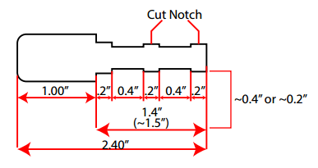
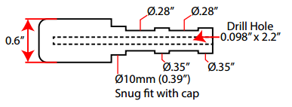
Body

Round a blank and cut a shoulder to place in a wood chuck.
Mount the blank in the wood chuck and square the end of the blank.
Mount a 0.098” drill bit into a Jacob’s Chuck and drill a 0.098” hole 2.2” deep into the blank.
Measure and mark 1.5” from right side of the blank.
Turn the right side of the blank down to a little bigger than 10 mm in diameter.
Measure and mark about 1.2” from the tail stock end.
Turn the blank to the right of this line to 0.35”diameter.
Turn the blank between the 1.2” and 1.5” lines to 10 mm in diameter. Use the cap to ensure a snug fit.
Once the cap fits snuggly, measure, mark and turn the remaining area on the right side to the dimensions in the drawings.
Finish rounding off the blank to a diameter to 0.6”
Finish and part off the body at 2.4” from the right.
Using an Exacto Knife, cut an angled notch in the two sections that are 0.35” in diameter. This will hold the thread in place.
